**EXPNO-5 LIBRARY MANAGEMENT**

**AIM:** Create a simple cloud software application for Library Management System using any Cloud Service Provider to demonstrate SaaS.

**Material:**

● ZOHO software.

● Data.

**Procedure:**

**Step 1:**

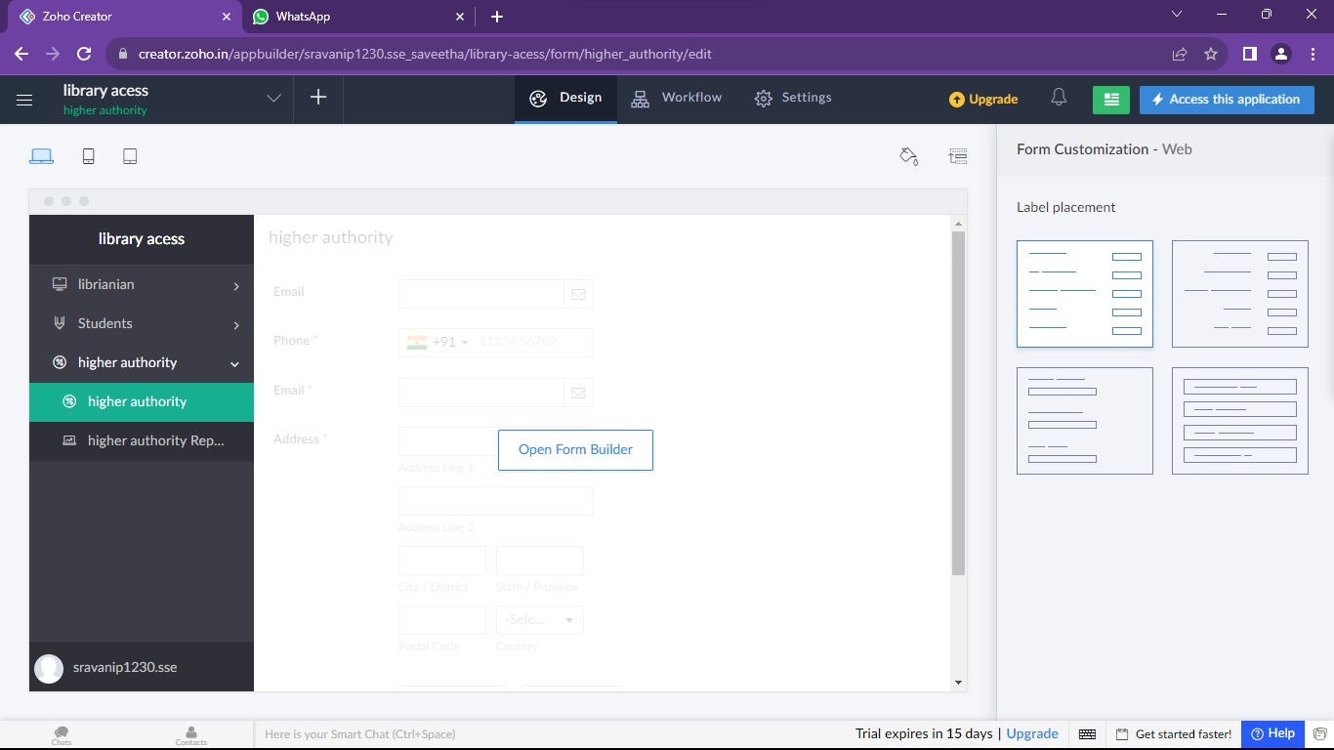

**Step 2:**

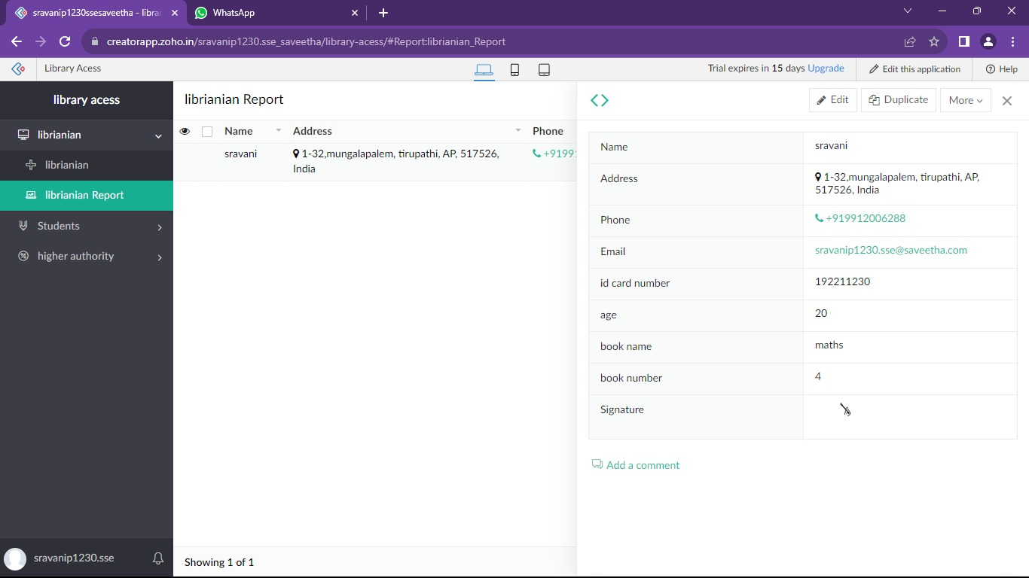

**Step 3:**

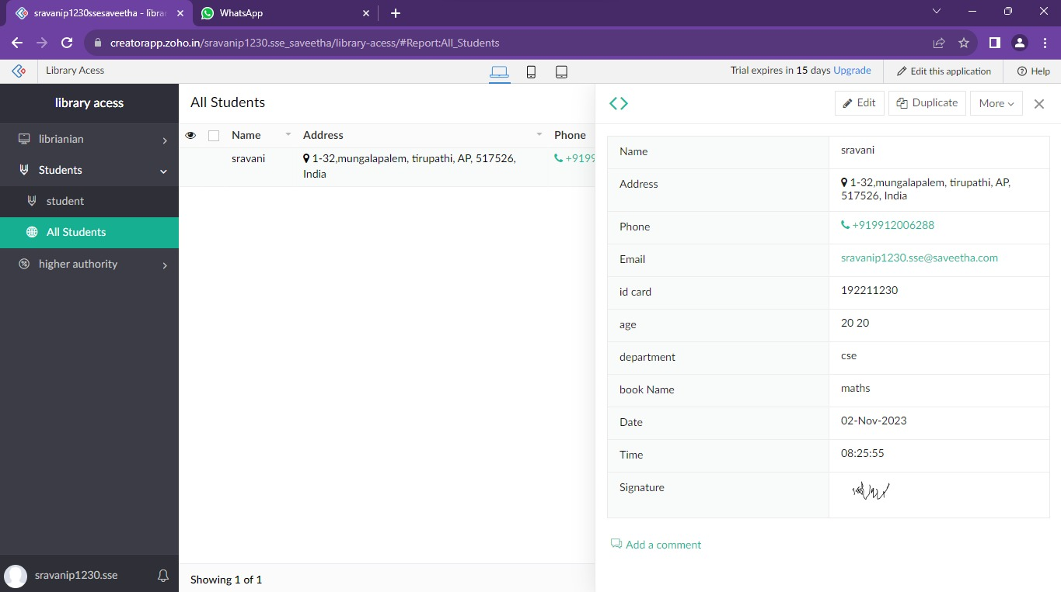

**Step 4:**

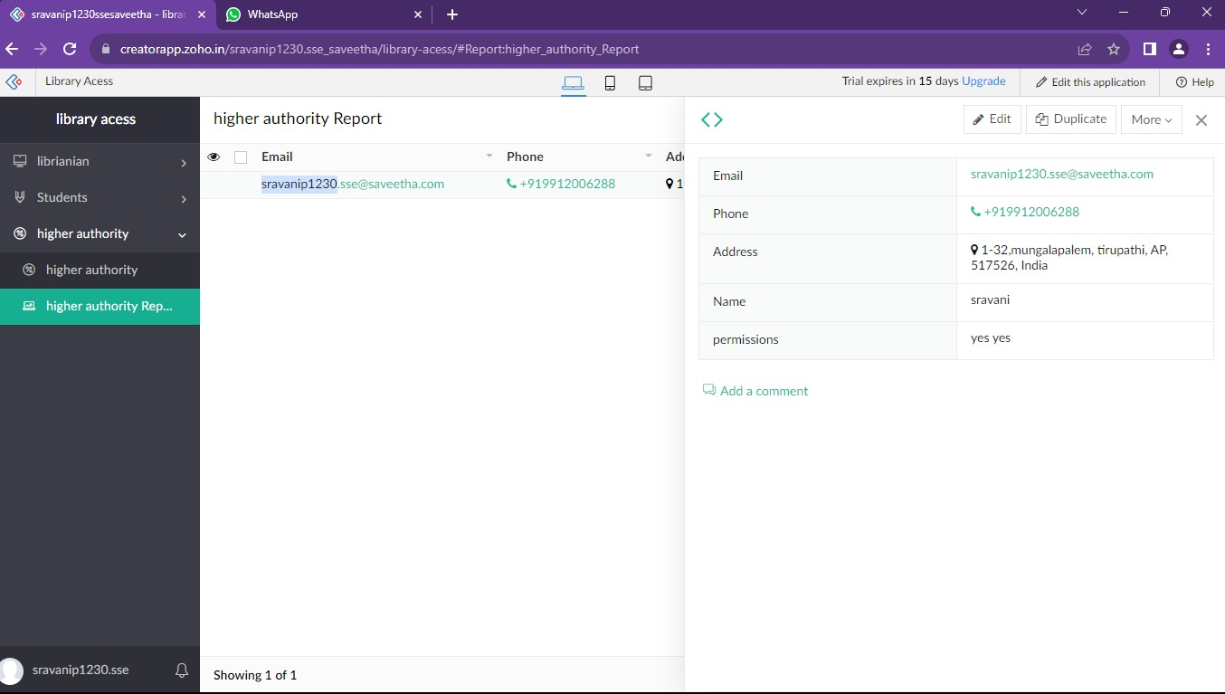

**Result:**

Successfully Developing a library management system with Zoho ensures scalable, secure, and integrated solutions for seamless user experiences**.**